# Handling Frames

## One HTML embedded with another HTML page.

# Two Approaches

## First get the frame by using framelocator()

## Using frame method(Path the name or URL of the frame) then only we can access the elements inside the frame.

# Approach 1: Using frame()

# To return all frames in page(array of frames)

## frames()

## frames() will return the frame and will store it in variable.

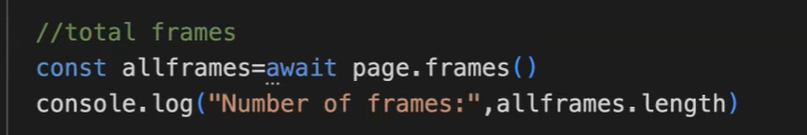

# A screen shot of a computer code Description automatically generated Approach 2: Using framelocator()

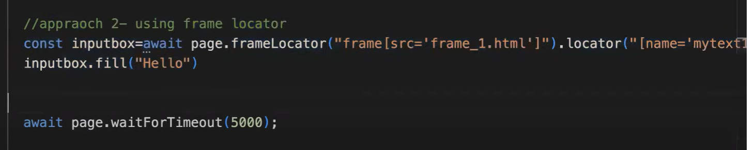

# Handling Nested Frame

## childFrame method will return all the frames present inside the parent(frame3) frame.

## This will return array of frames.

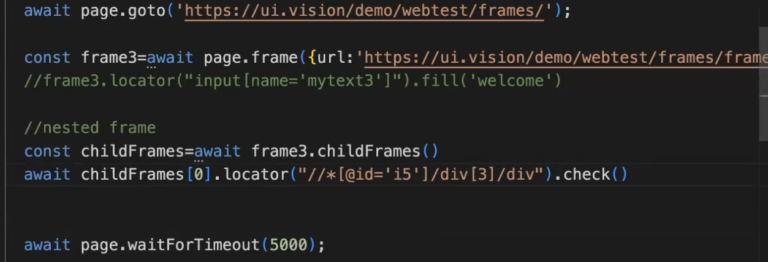

# Capture Screenshots

## Using screenshot() method.

## Pass two parameters: Exact path where screenshot should be saved and name of the screenshot.

## Date.now() – current date and time

## In specific place and section if we want screenshot use then approach.

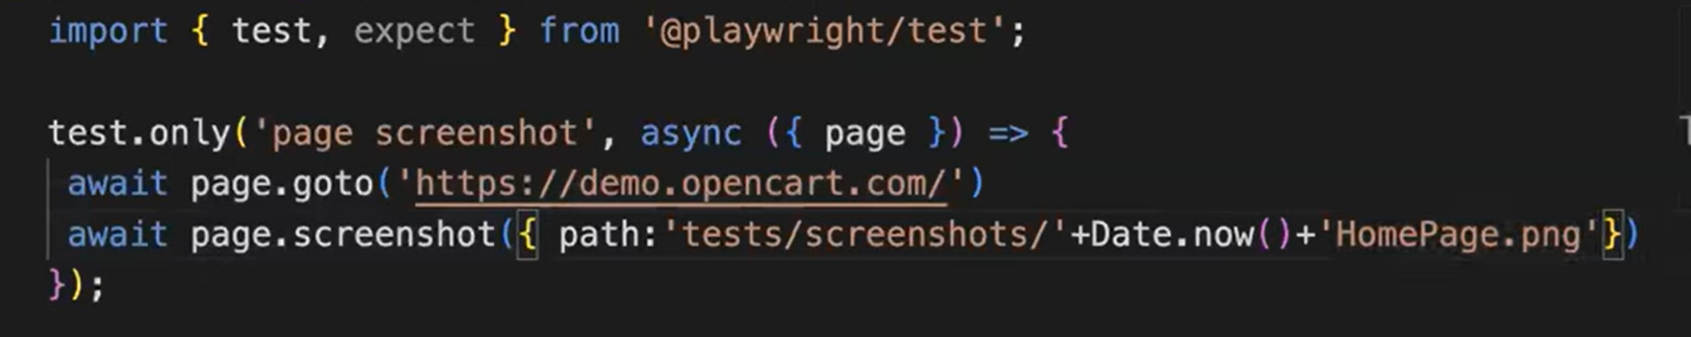

## To capture full page pass one more parameter **fullpage:true**

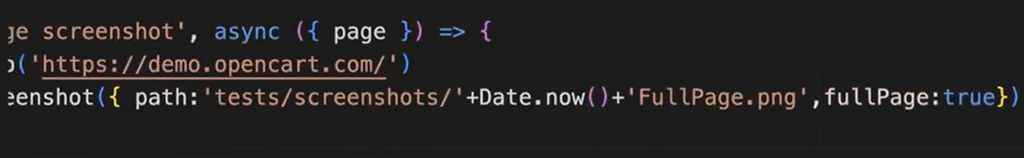

# Specific Element Screenshot

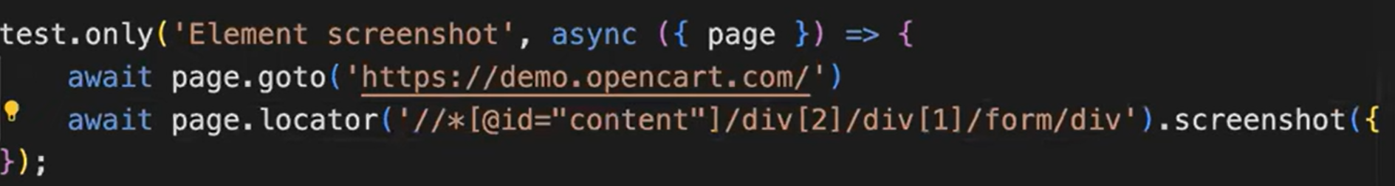

# Whenever I run the test, I want to capture the screenshot of every test:

## In playwright config file under use block provide **screenshot:on**

## We can see the screenshot in test-results folder.

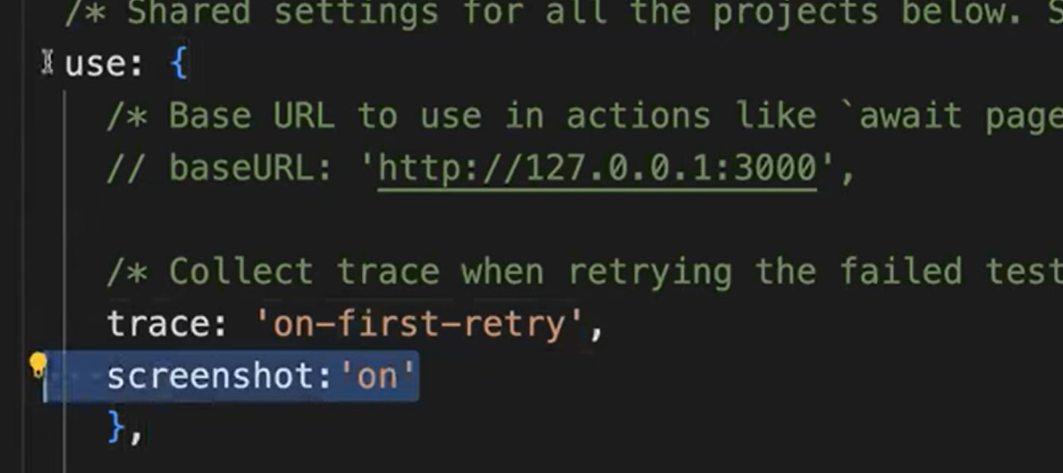

## In reports also it will be automatically appeared.

# Screenshot only on failure:

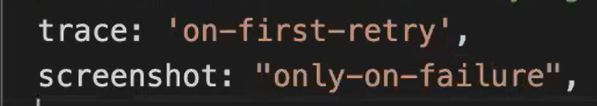

# Recording Videos

## In playwright config we must set video

## In test-result folder we can see the video folder generated. It will play on report directory.

## In report also It will be automatically attached.

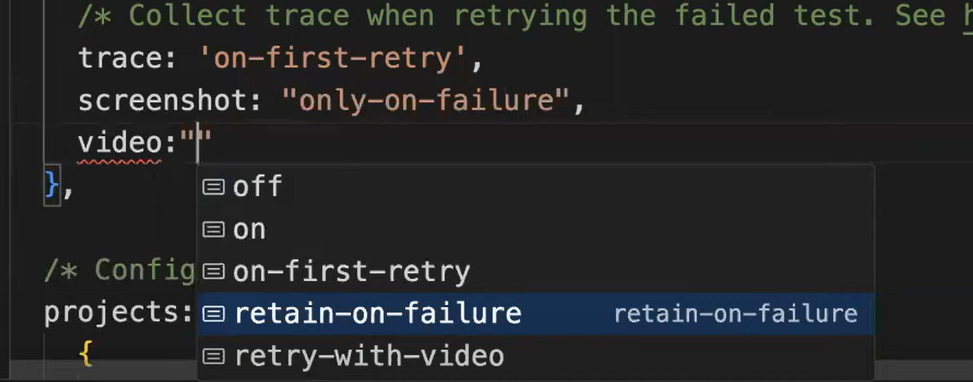

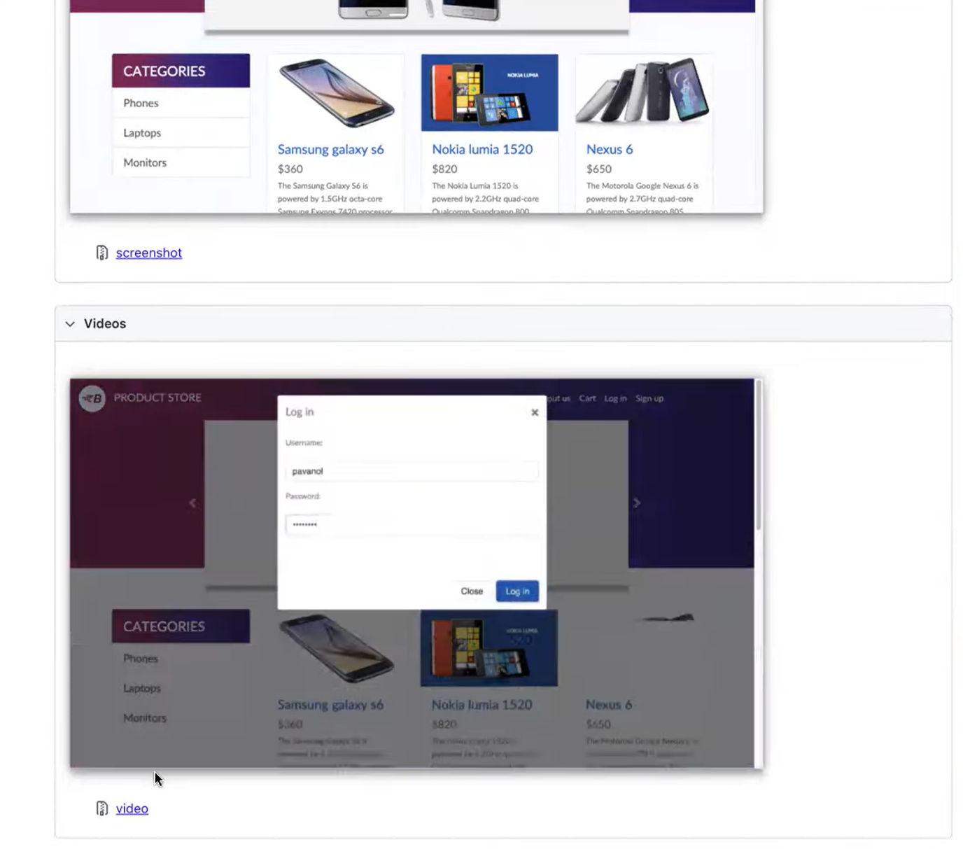

# Trace Viewer

## Easily trace the failures.

## Get detailed information.

## In playwright config file we must mention trace options.

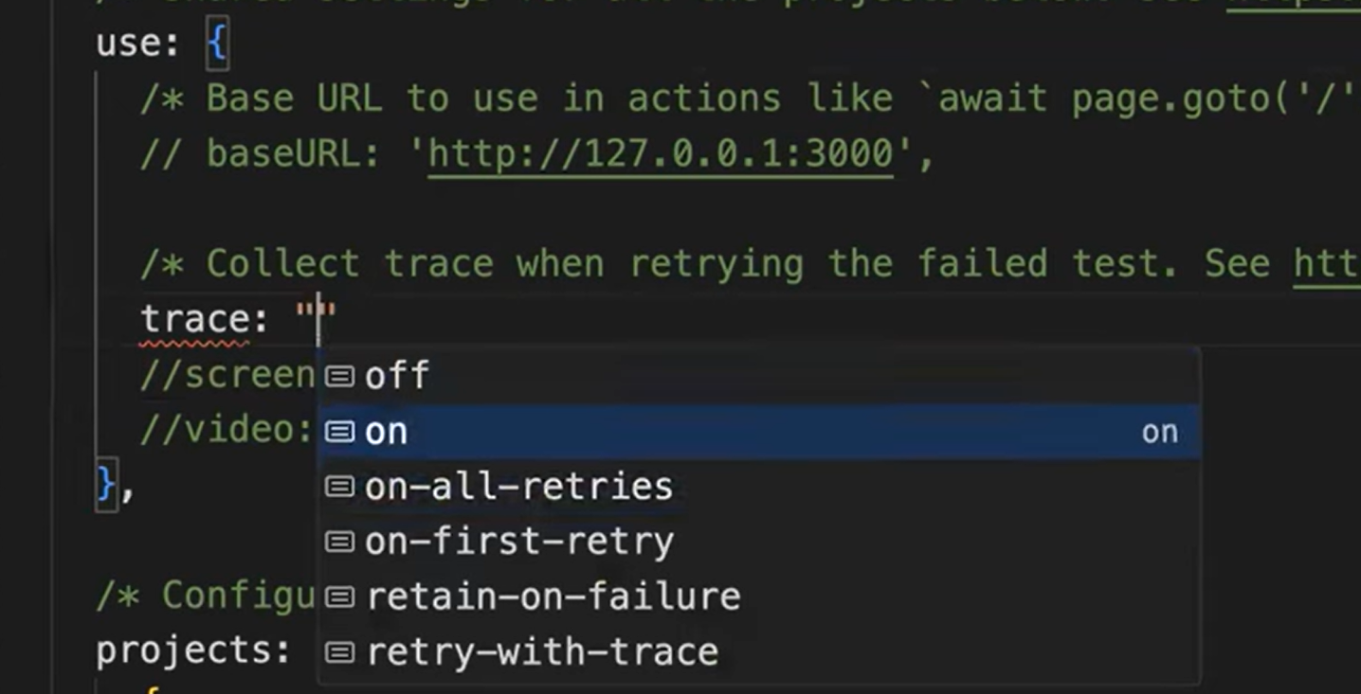

# View the Trace

## Execute below command in cmd line.

## The file will be created in test-results folder.

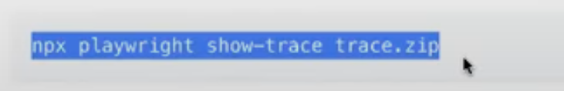

# To open



## It will look like a movie reel.

## Under Actions each action whatever is performed will be displayed.

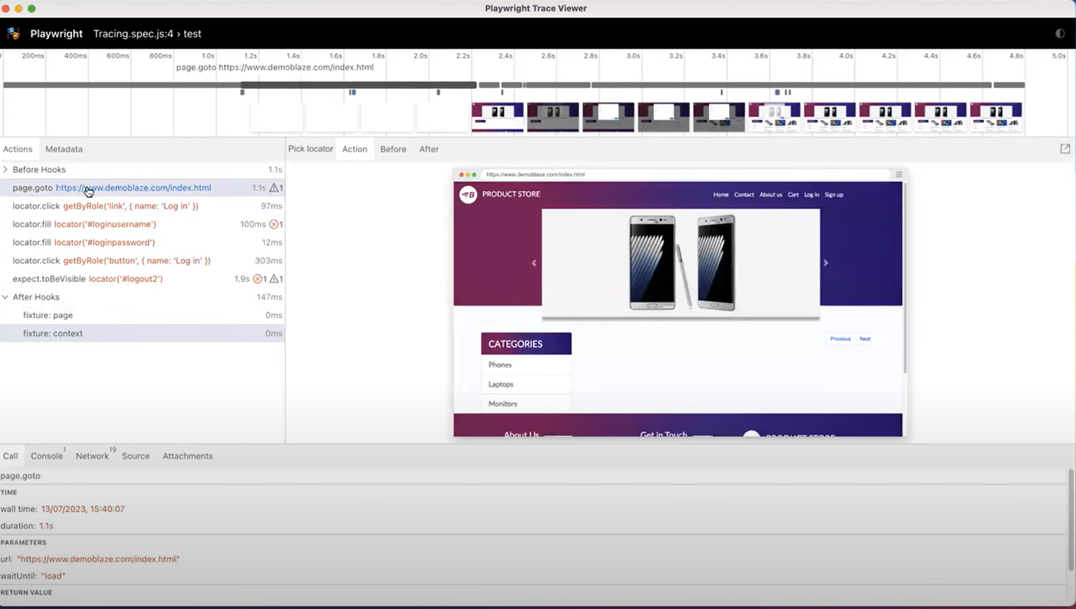

# Handling WebTables

## To know the **column count** – if we know the **th** count then we can get the columns count.

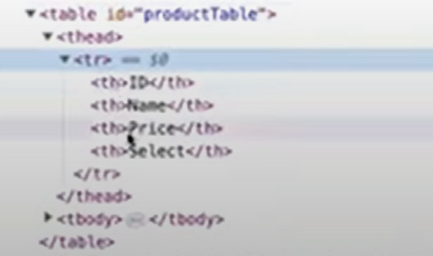

## To know the **row count** – if we know the **tr** count then we can get the rows count.

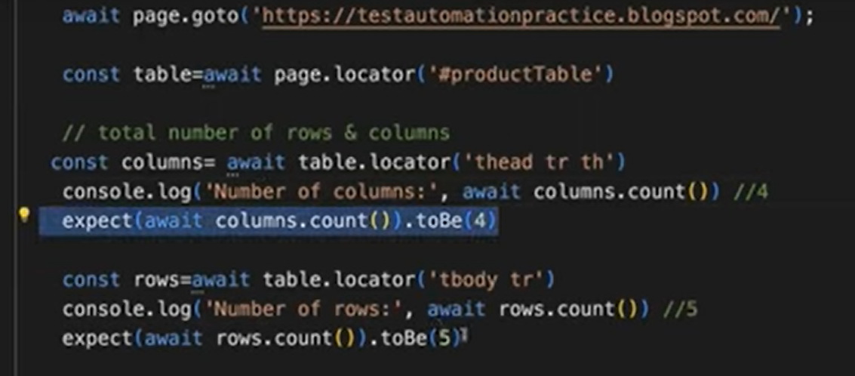

## filter() – This is used to filter specific rows.

## All the data inside the table is part of **td** tag.

# Process

## From multiple rows we have extracted the specific row based on filter options and stored it in the variable matched row.

## Once you get all the rows apply filter function.

## Inside filter we have provided two filter options

## First based on td it will filter all data.

## Second it from that data it will extract the specific text.

## Finally, inside that row we captured the checkbox and checked it.

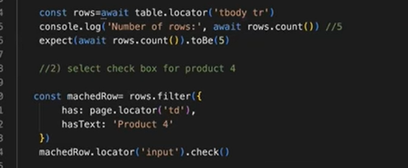

# Select multiple checkboxes in table:

## Create reusable function outside of test function block.

## For creating function in JavaScript, we use **function** keyword.

## All the rows, page fixture and product name we must pass.

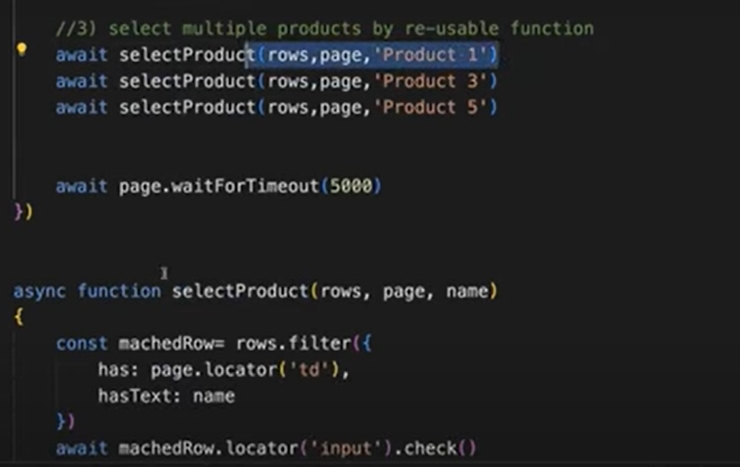

# How to capture all data from all Pages in Pagination table

## We must write nested for loop.

## For loop for row iteration

## Extract each row and store in a variable.

## Gives all tds which are present inside the particular row.(td represent columns data)

## For loop for column iteration(td represent column so (tds.count), we don’t need last Column since it does not contain data so add -1)

# Process

## Before getting column data first we must capture particular row.

## From multiple row we must extract first row and get all tds from particular row.

## Read all tds from second for loop using text content.

# Single page code

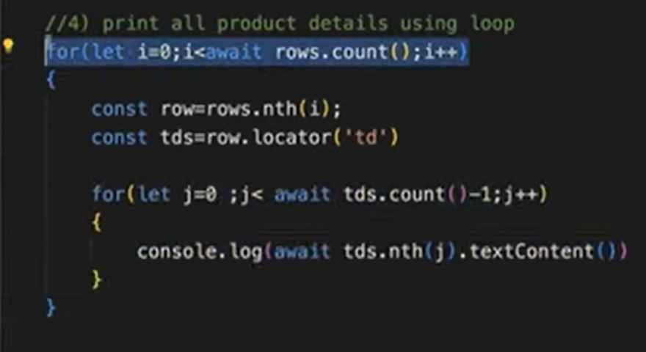

# Handling pagination(Multiple page code)

## First page we don’t need to click on the next button only to move to second page we have to click below page button.

## So, p>0 only we have to move to next page.

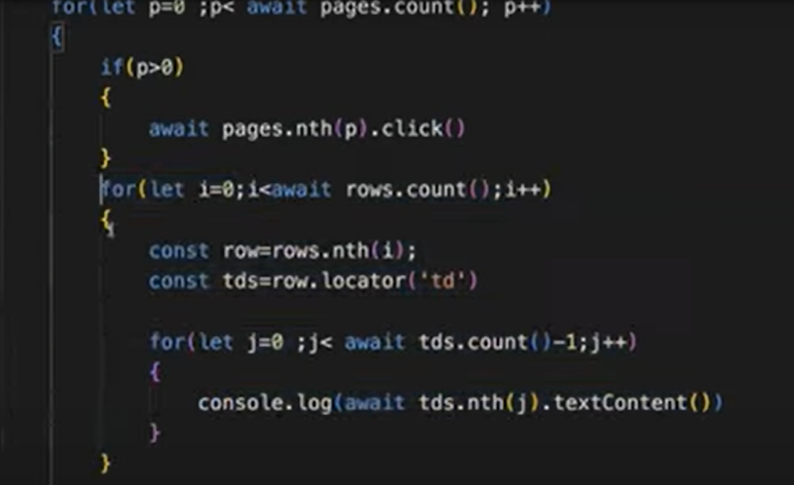

# Handling Datepickers:

## It contains multiple elements. It is customized.

## Depends upon the design of date picker we must write the code. It will not be same in all application.

# Using Fill method

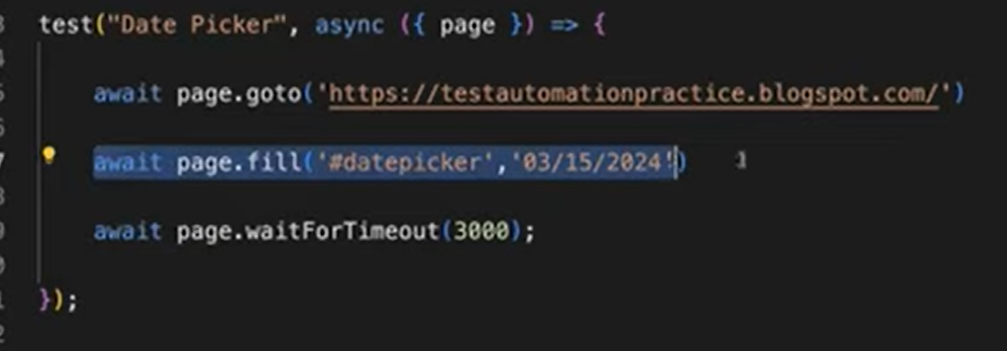

# Sometimes if it didn’t allow to fill then use logic.

## Which year want to be selected.

## Which months want to be selected.

## Which data want to be selected.

## We have compared actual month and year with expected month and year. If not matching, we must click next button until we get the expected month.

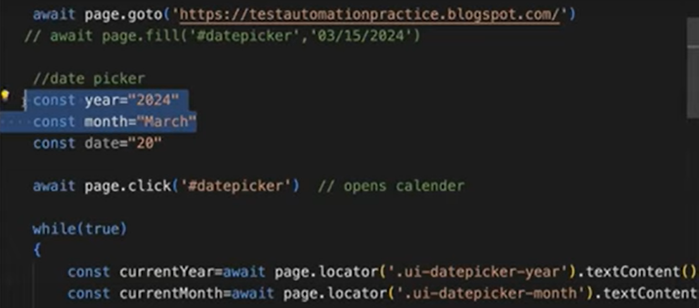

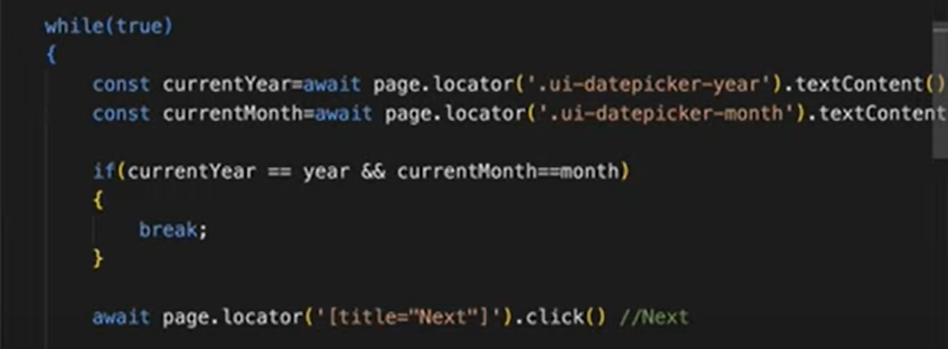

# Select date in array concept:

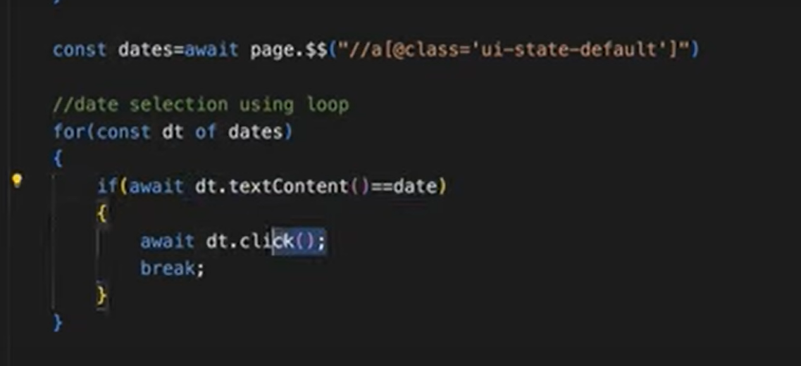

# Select date without loop:

## This is the method to parameterize element in JavaScript.

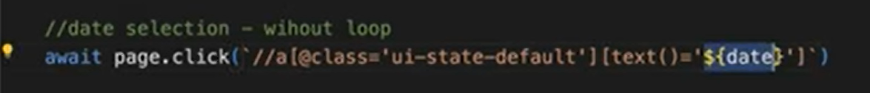

# Mouse Hover Actions

## In Playwright we have direct method.

## Use hover() method.

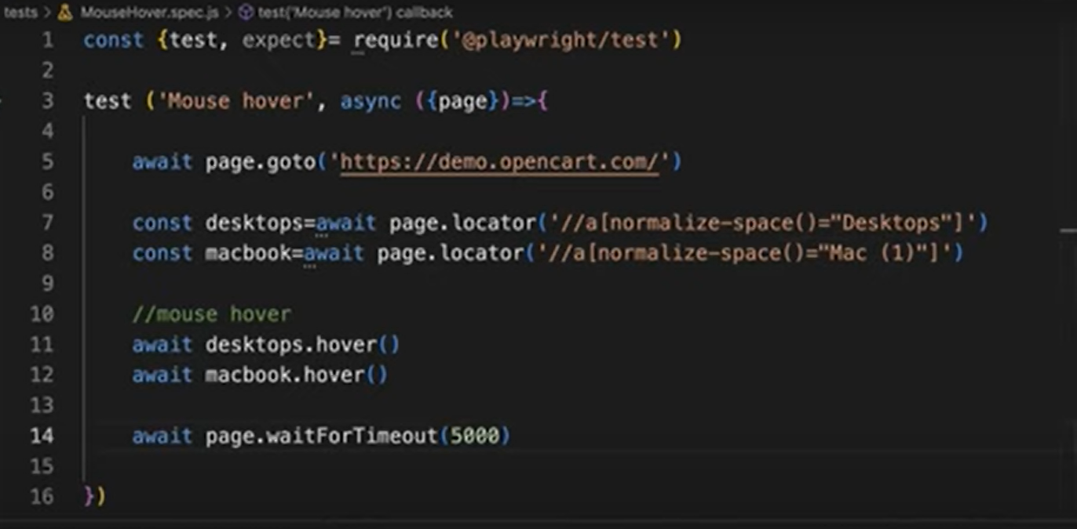

# Mouse right/context click:

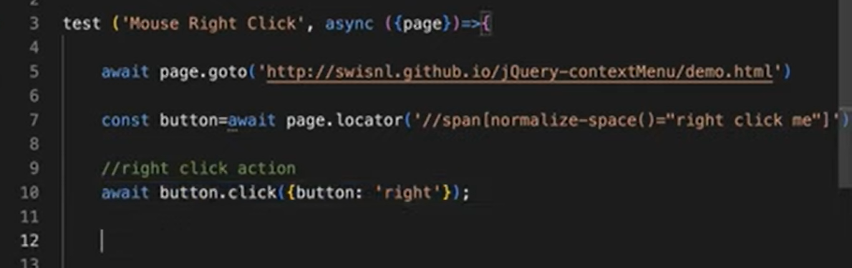

# Different click options

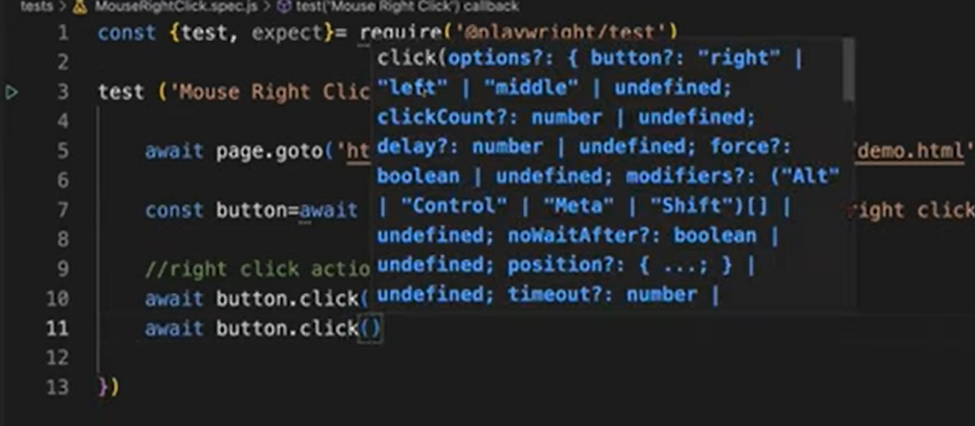

# Mouse Double Click

## In Playwright we have direct method.

## Use dblClick() method.

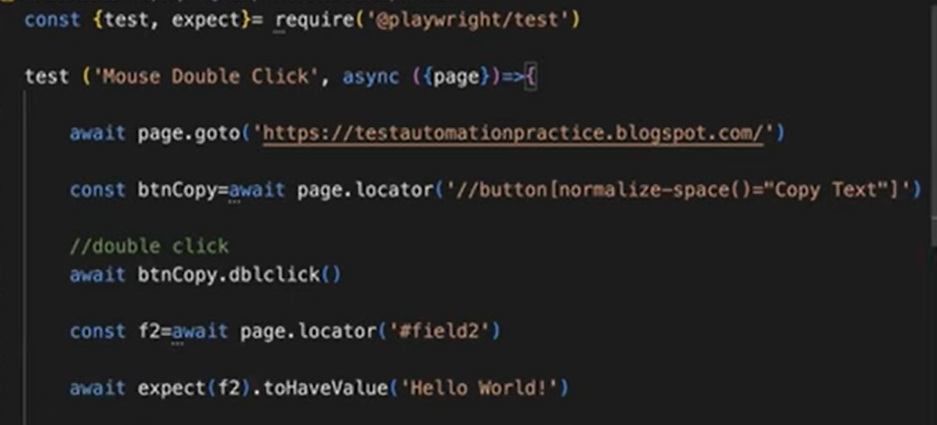

# Drag and Drop

# Two Approaches

# Approach 1

## Mouse Hover on source element

## Click that element.

## Mouse Hover on target element

## Release the element.

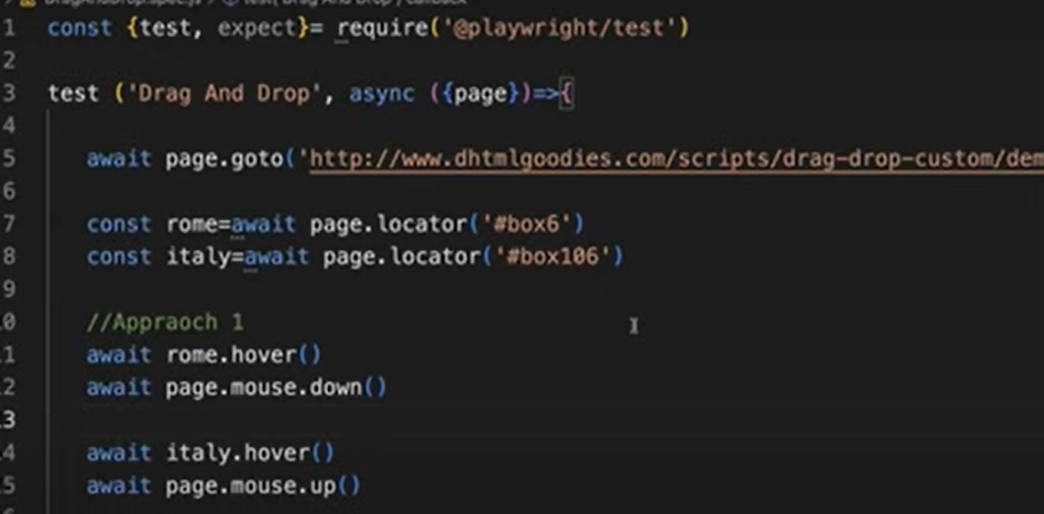

# Approach 2:

## Use dragTo() method

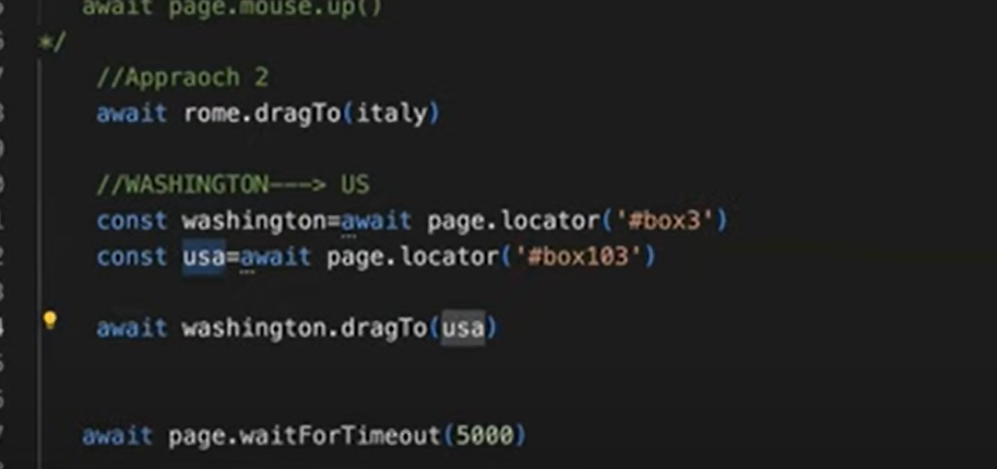

# Handling Keyboard operations

## We have special **class** called **Keyboard**. In which we have different types of **methods** by using it we can perform keyboard actions.

## First access the keyboard

## Use press() to whenever we want to use combination of keys(ctrl+A etc)

## For pressing tab key use **down()** method.

## For releasing tab key use **up()** method.

# In Mac instead of control they use Meta

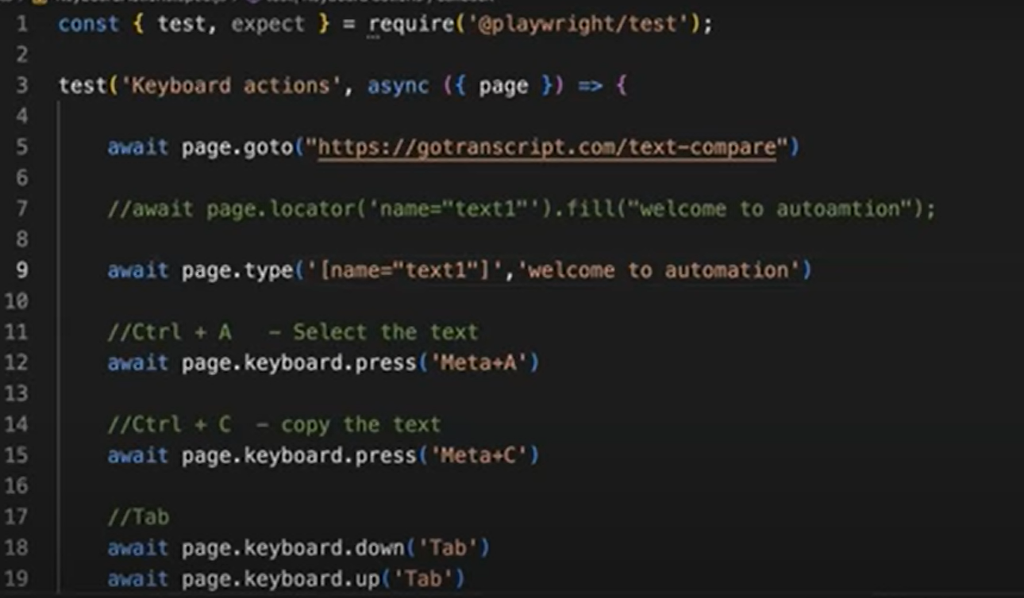

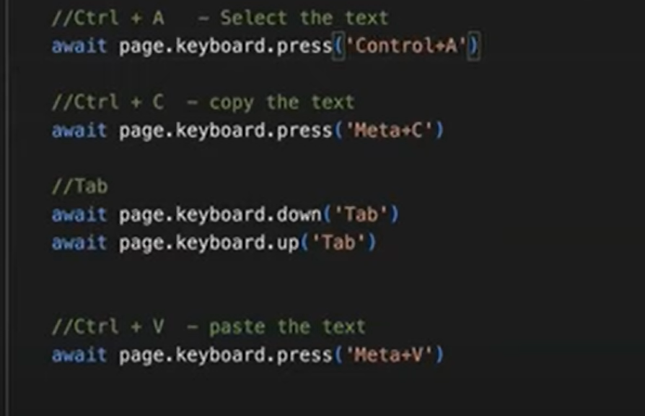

# Upload Files

# Single File

## Select files from the desktop. Playwright is for web application it cannot automate desktop application.

## Playwright provided one method called setInputFiles().

## We don’t need to browse any files just set the file path inside the method. It will automatically upload file from that path into application.

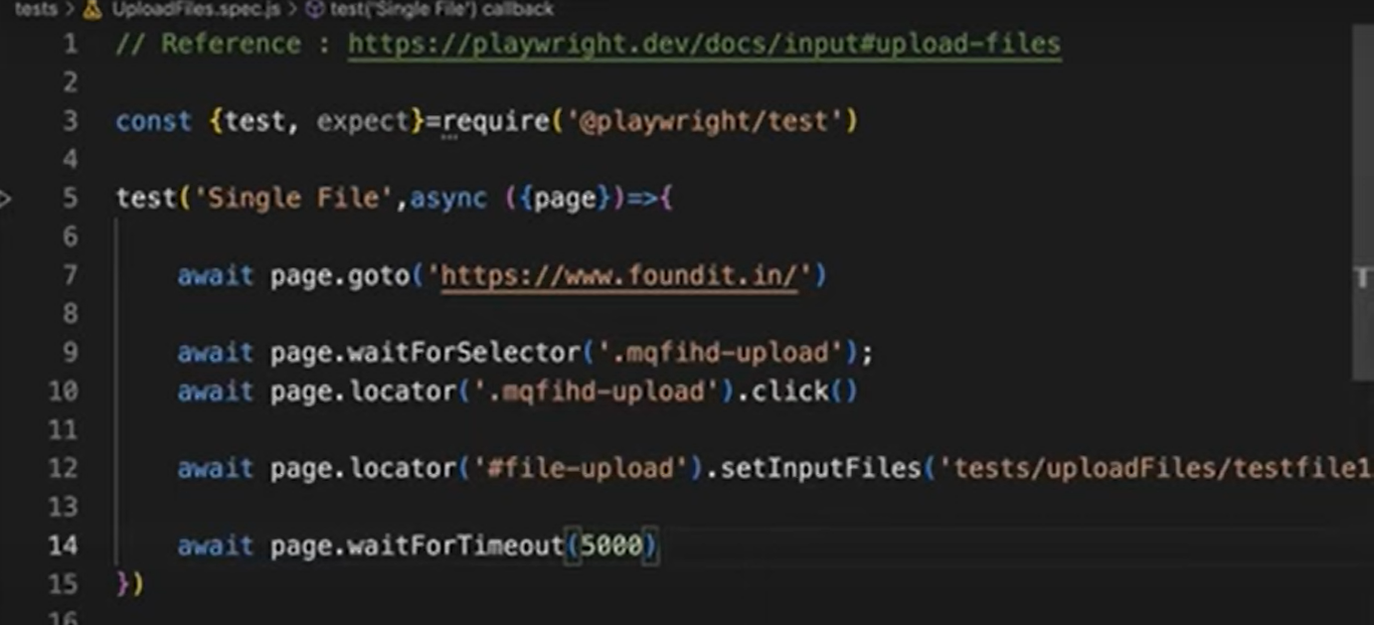

# Multiple Files

## Send the files in form of array.

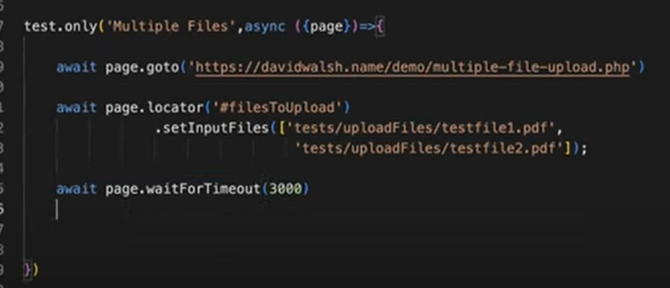

# Verify files attached are not:



# Remove files:

## Just pass empty array to remove the files.

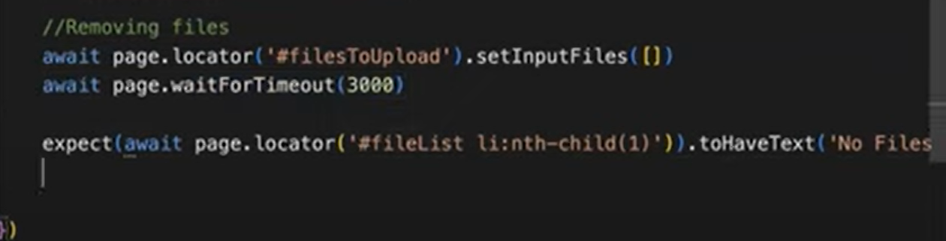

# Hooks

## Playwright provides 4 types of hooks.

## We must do some configurations before using this hooks concept.

## fullyParallel : false

## workers: By default 3 workers will be assigned for every test(firefox, chromium, etc)

## make workers:1

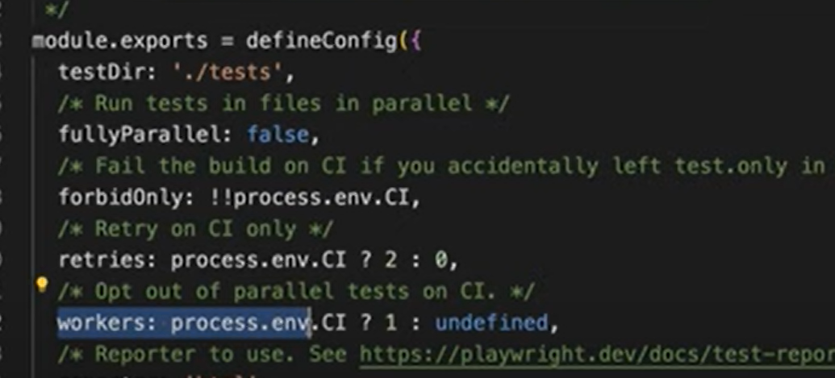

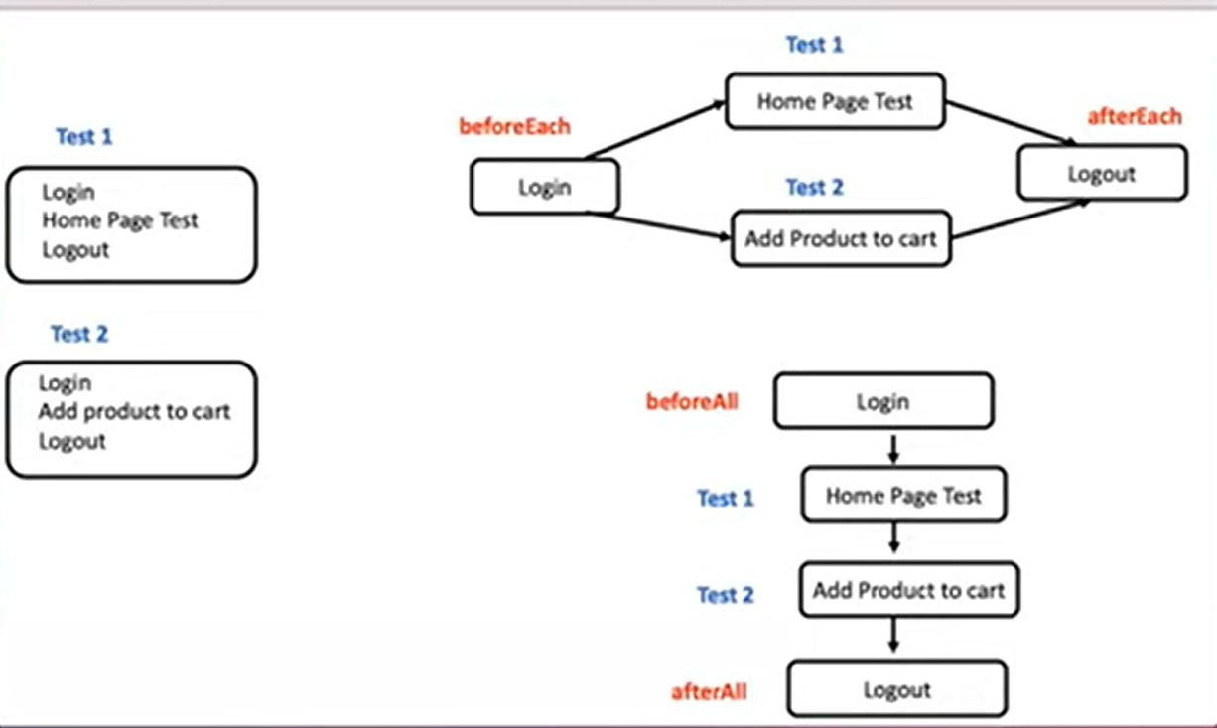

# beforeEach

## It will execute multiple times before each test starts its execution.

# afterEach

## It will execute multiple times after each test is completed its execution.

# beforeAll

## Execute only once before starting execution of all the test.

# afterAll

## Execute only once after completing execution of all the test.

# Process

## Get the browser fixture.

## From that browser fixture we are creating new page using new Page. This the page element which we are going to refer in every test.

## Globally declaring the page variable to be access/used inside entire test.

## We are going to use the one page which will refer in every test.

## Since we are going to use the same page in every test all the test blocks and after each also should not include page reference in the parameter.

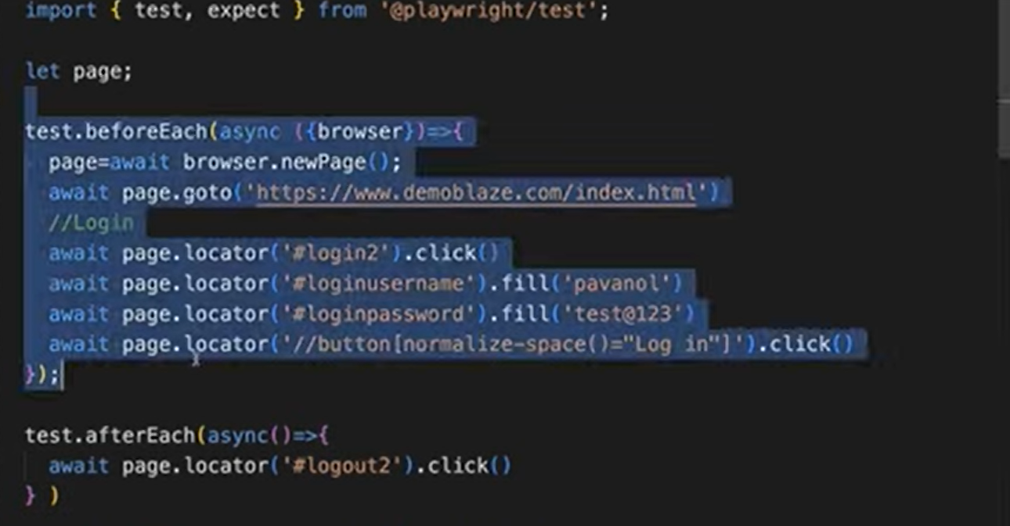

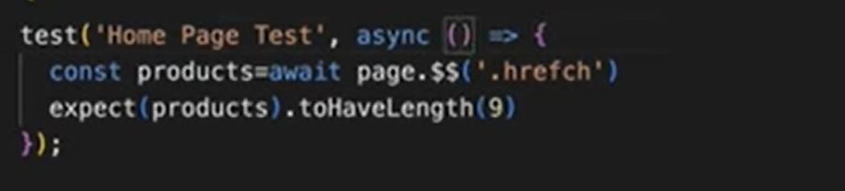

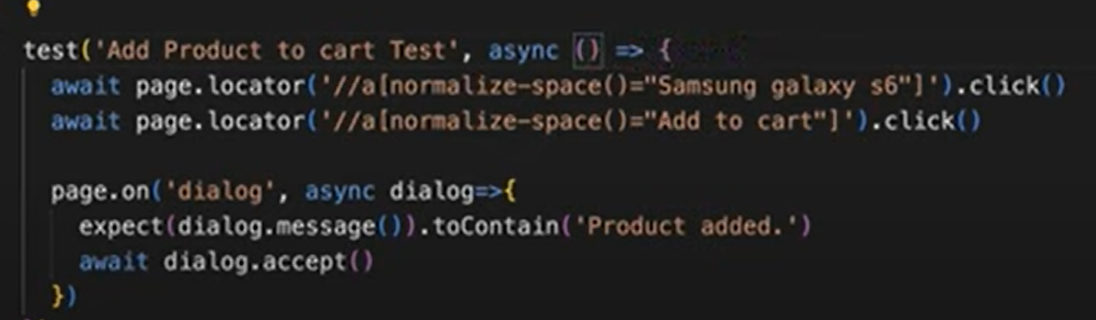

# beforeAll and afterAll

## When you write test blocks it will accept page fixture.

## But for hooks it will not accept page fixture directly. If we want to create a page reference first, we want to get the browser fixture then from that browser we must create new page.

## If we take page fixture direct in hooks in runtime, we will get an error.

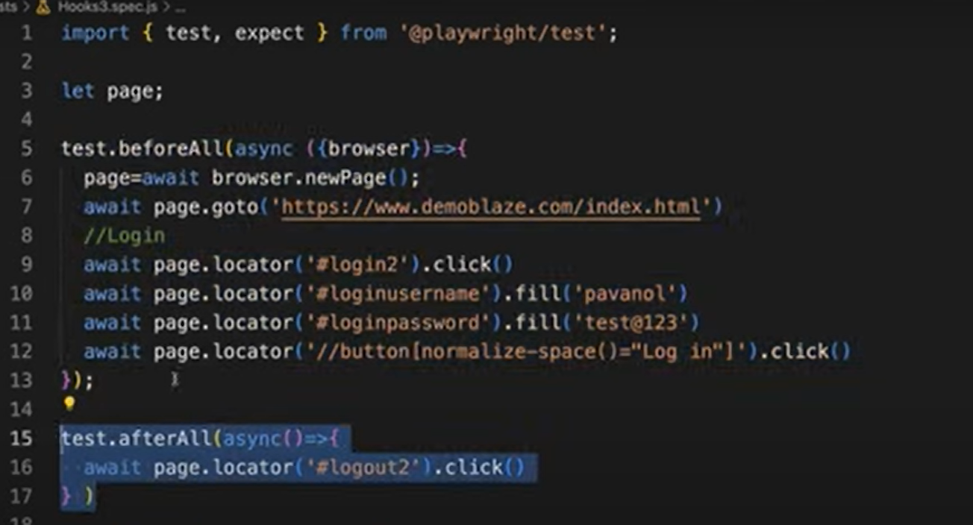

# Grouping Test

## Sometimes we have n number of test cases. We need to group them into multiple categories like functional, regression, sanity etc.

## **Describe(represent group)** block – It is like Test suite. All the test we can keep inside describe block.

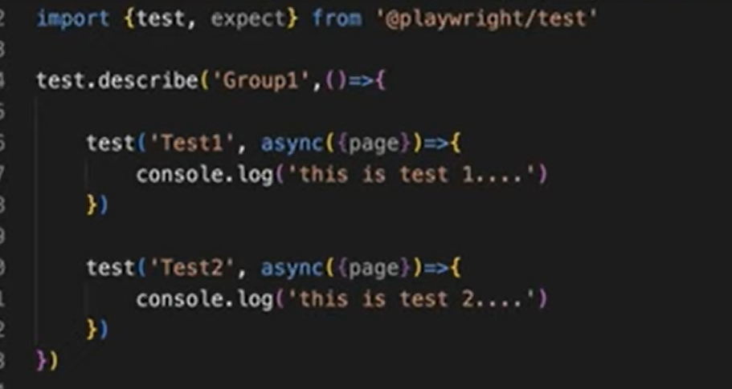

# Before writing all describe block, we can include hooks:

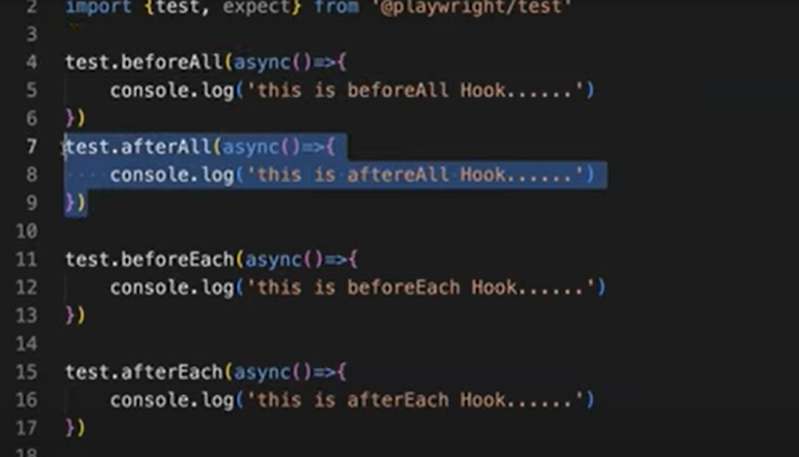

## If we want to execute only specific group of tests, then mention **only keyword.**

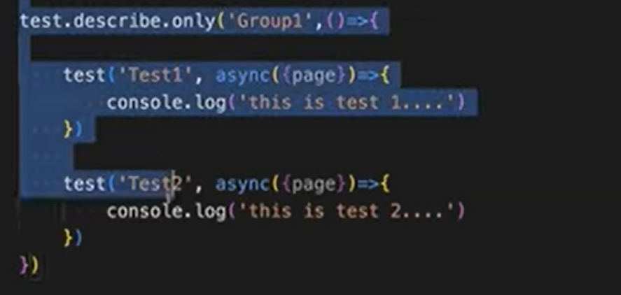

## If we want to execute skip/ignore specific groups of tests, then mention **skip keyword.**

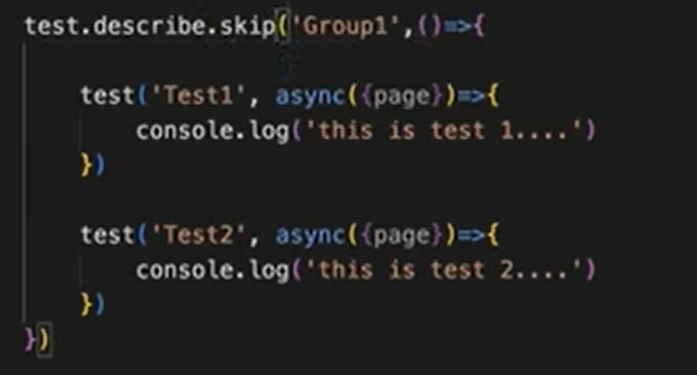

# Trace Viewer

# Metadata

## Start time.

## Duration

## View port

## Browser size

## screenshot

## Every automation step inside its multiple API calls will get executed. In Network you can see that.

## Which statement we are currently pointing in source code we can see in source Tab

## Every timeline is captured, and we can see that by moving.

## Before and after actions will be highlighted.

## It will automatically give the locator path using pick locator icon also.

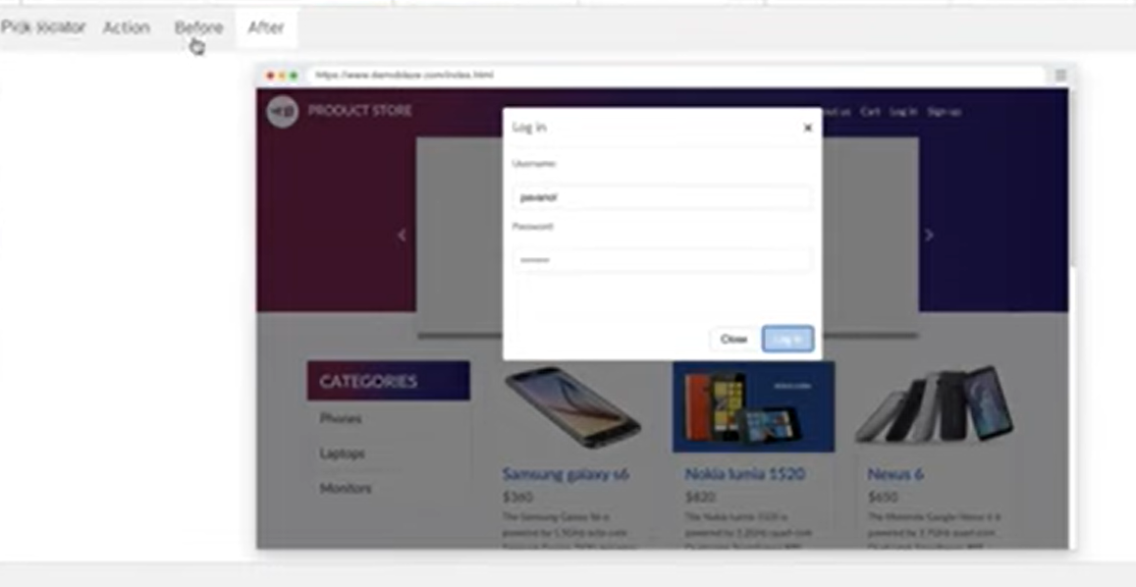

# Tag in playwright

## Should add tag along with the test description.

## If we want to execute only the test which has sanity tag as below

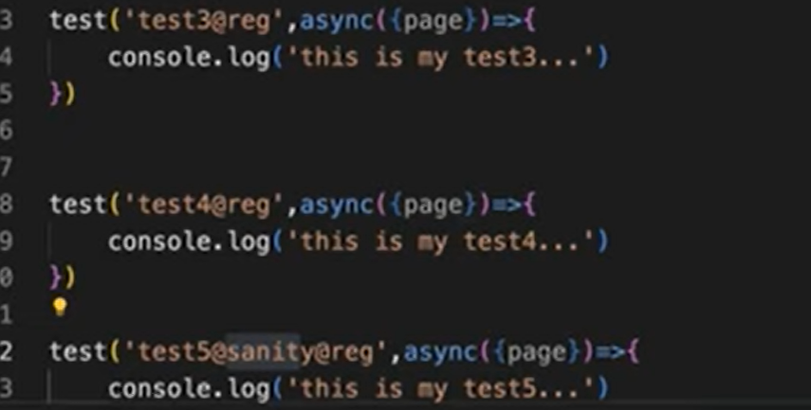

## Run the below command**(--grep @sanity)**



## If we want to execute both tag like sanity and regression

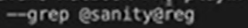

## If we want to execute only sanity but part of regression should skip(@sanity@reg)



## --grep @sanity – included tag

## --grep -invert @reg – should be excluded

# Annotations

# test.only()

## If we want to execute specific test among multiple test then use test.only().

## You can focus some tests. When there are focused tests, only these tests run.

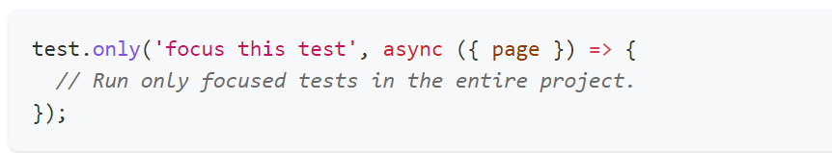

# [test.skip()](https://playwright.dev/docs/api/class-test#test-skip)

## This test will not be executed. It will be ignored and skipped.

## Sometimes we can skip the test based on certain condition. If the browser name is chromium, then it will be skipped. If it is not chromium then it will not skip the test it will execute.

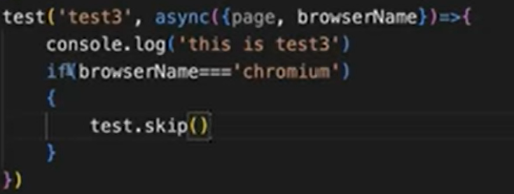

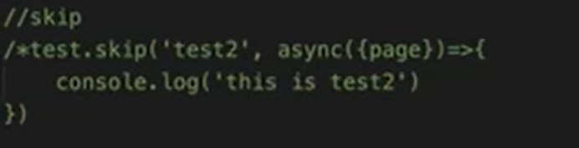

## Marks the test as irrelevant.

## Playwright does not run such a test. Use this annotation when the test is not applicable in some configuration.

# [test.fail()](https://playwright.dev/docs/api/class-test#test-fail)

## Expecting test to be fail but if it actually passed. Both are mismatch. That’s the reason test got failed.

## Expecting test to be fail and actual test is also failed. Both matches. That’s the reason test got passed.

## Used for Negative testing.

## We can also fail the test based on the condition.

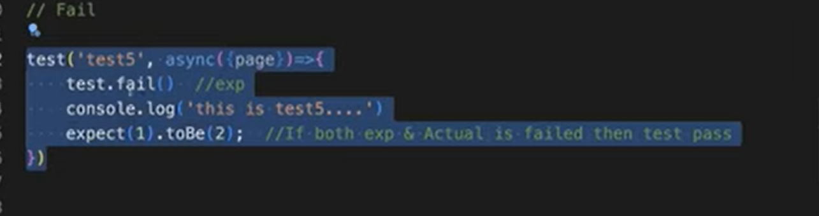

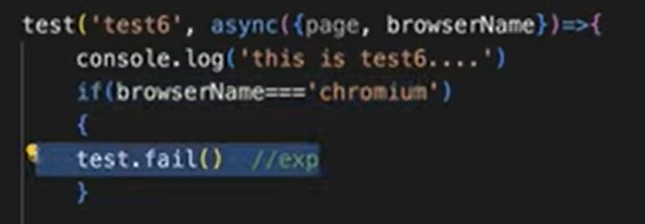

## Marks the test as failing.

## Playwright will run this test and ensure it does indeed fail. If the test does not fail, Playwright will complain.

# [test.fixme()](https://playwright.dev/docs/api/class-test#test-fixme)

## If the test is having any open issues or test having bugs or known issues. Till I fix the automation test then I use this fixme.

## Marks the test as failing. Playwright will not run this test, as opposed to the fail annotation.

## Use fixme when running the test is slow or crashes.

## We can also use fixme the test based on the condition.

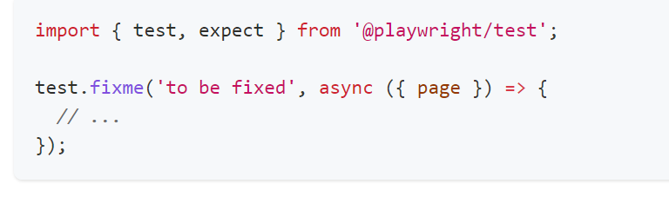

# [test.slow()](https://playwright.dev/docs/api/class-test#test-slow)

## By default, every test will take to wait for 30 seconds for every test.

## Marks the test as slow and triples the test timeout.

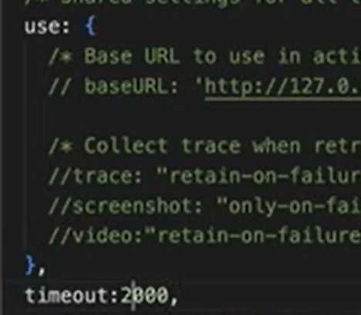

## If we use timeout option in config then it will wait for mentioned time(1000) instead of default time.

## If we specify timeout:1000ms in config file but in one test block if we use this slow method this will tripe the time for that specific test.

# For specific test level if I want to apply the time

## If we give timeout:1000 in config then it will be applicable for all the test but for specific test only if we want to set time out, then use below format.

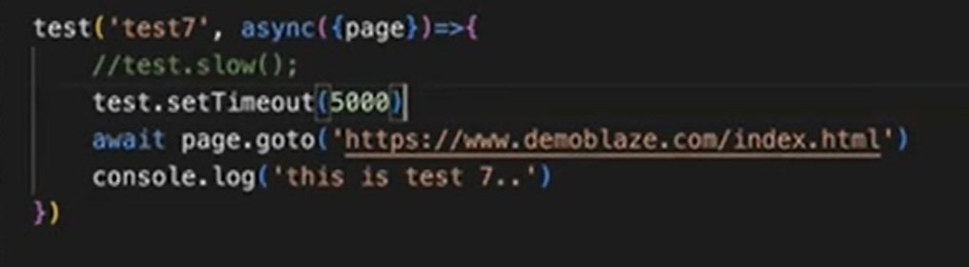

# Page Object Model

## Design Pattern

## Maintain page elements in separate files.

## Every page will contain separate files.

## If we didn’t use POM below problems we face.

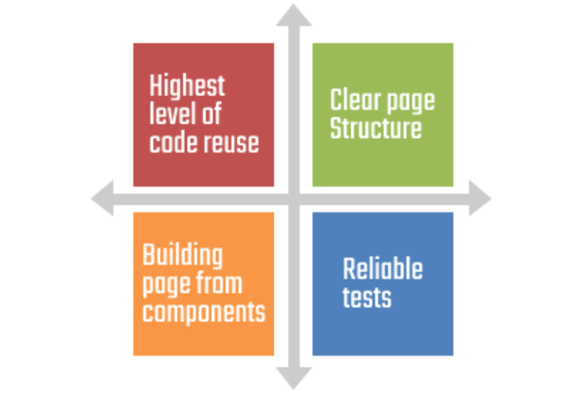

# Two problems:

## If login page elements obviously will be used in multiple Test cases so in that case multiple time, we must locate the elements. Not good practice. Waste of time and effort.

## If this login page element is used in 10 test cases if there is change in any of the locator, then in every test case we must modify it.

# Solution

## Let us assume there are 10 pages in the application every page we will create a separate file and we call them as page object classes.

## This class file contains page elements and its corresponding actions.

## For login page we create separate PO file which contain only login page elements along with the actions. Same for all pages.

## Based on the Test Cases whatever element are required we can add that alone initially no need to include all the elements present in the Specific(login) web page.

# Steps

## Whenever we create a new test, we pass the page fixture as parameter. The page fixture is created by playwright which is already available.

## Whenever we create a Page object class first thing is we must create a class like this.

## Class and name of the class(LoginPage).

## Inside the class we need to create one constructor.

## Whenever you create an object for this class the constructor will automatically invokes.

## Inside the constructor we must take page fixture as the parameter and using that same page reference we are going to refer the elements.

## Assigning page local variable(page) to class variable(this.page)

## this keyword is always representing the class.

## We maintain all the locators inside the constructor.

## Once we created the class we make to make this class access by other classes/test.

## For that we use **export.LoginPage** to export this class

## Whenever you are exporting this class, we will be able to import this in another file/class. If we do not export this class, we cannot import it in another file.

# To use that page in test file

## So now we will be using that login page element in our test file, so we must import it into test file.

## Now create an object of Loginpage.

## New Loginpage() will create an object and that is referred by the variable login.

## Whenever you create an object for Loginpage here Loginpage contains one constructor, and this constructor will automatically be invoked and at that time it will expect page fixture/object so we have to pass that inside the constructor.

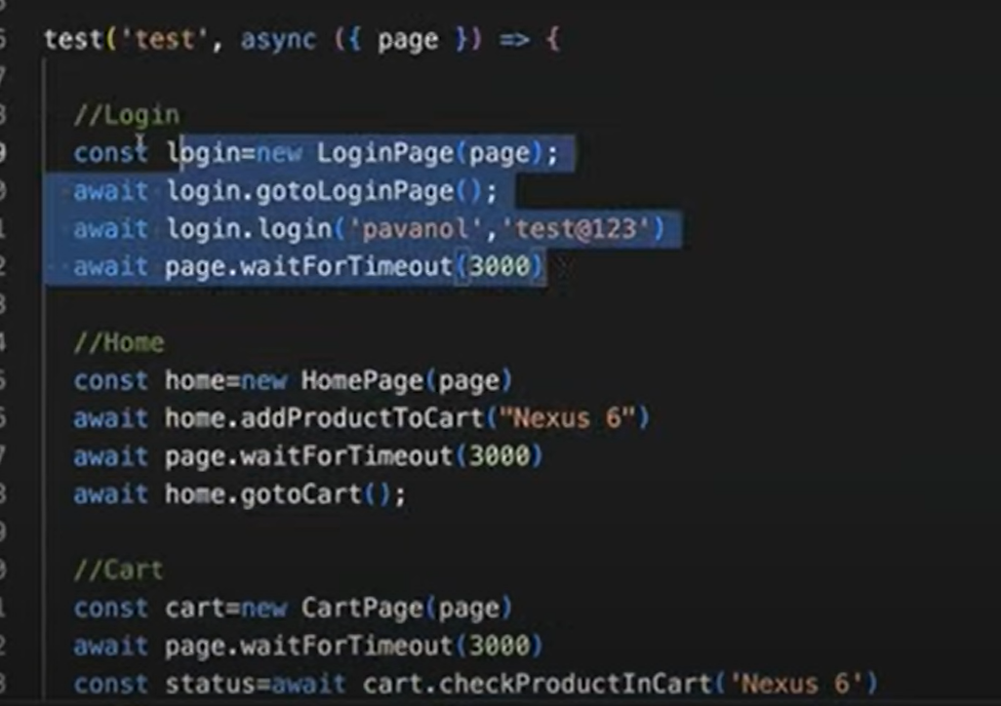

# Product Page Explanation:

## This will take the productname as the parameter.

## $$ represents multiple elements whenever we want to get all the element in form of array we have to use this $$.

## Getting all the product list and storing it in a variable

## Read each and every product .

## If the expected product name is same as the actual product name, then click on the product.

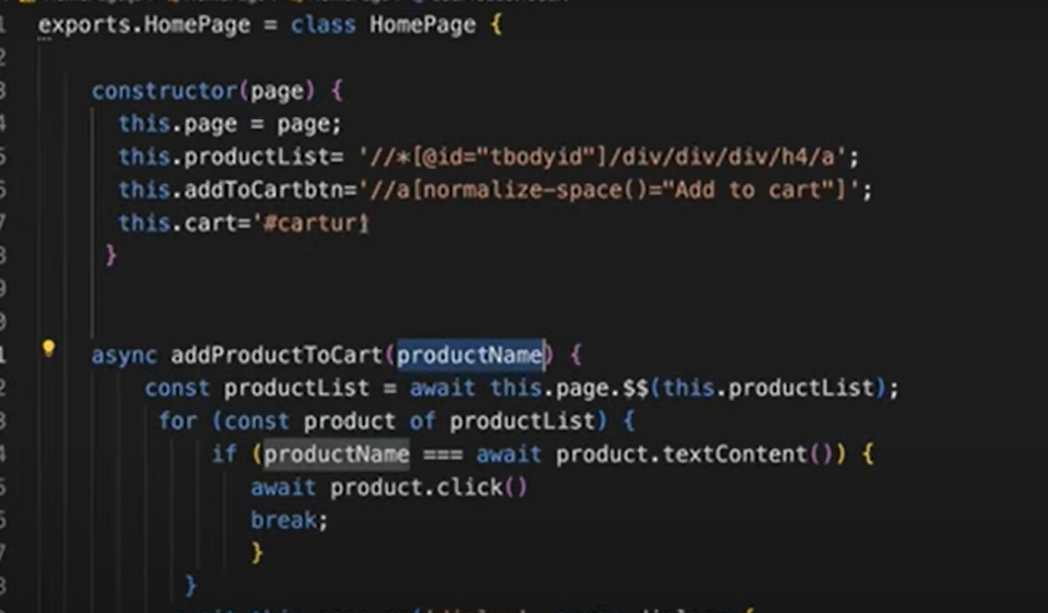

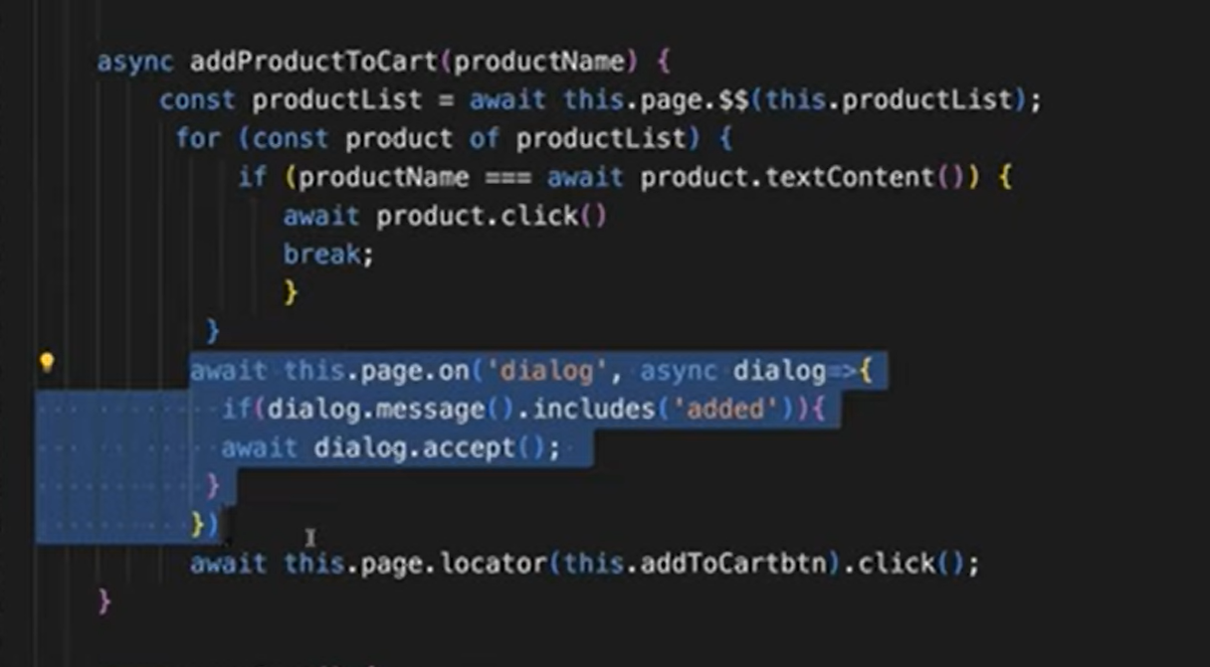

# Handle multiple pages/multiple windows both are same:

## If you want to handle multiple browsers or multiple windows, we must create our own page.

## We create that page using browser context. If we want to create browser context again, we must create browser.

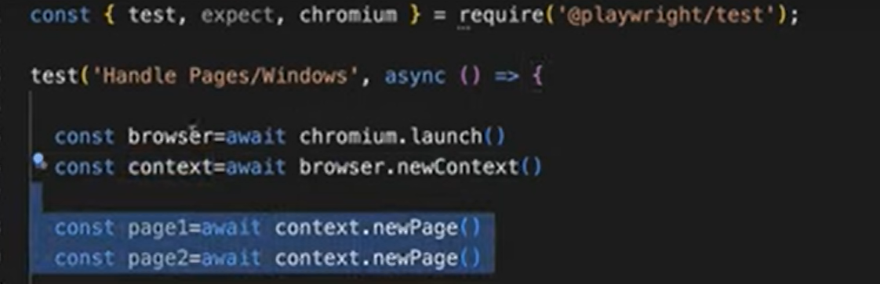

## First, we must create browser. From browser we can create browser context and using browser context we can create multiple pages.

## First, we are launching the chromium browser using launch() method and creating one browser instance and storing in it.

## Now using this browser instance, we will create browsercontext and store it in context instance.

## Whenever you create the context inside the context, we can create multiple pages.

## Using this context we can create new page and store it in page instance.

## Similarly I can create another page using same context.

# To get pages available in context

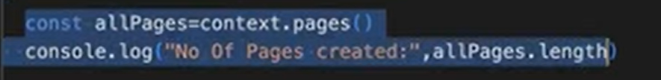

## This method will get you all the pages which are there in the same context.

## This variable holds all the pages.

## There is no connection between these two pages.

## Even though they belong to one context those two pages are completely independent and different.

# Open two different URL in two different pages

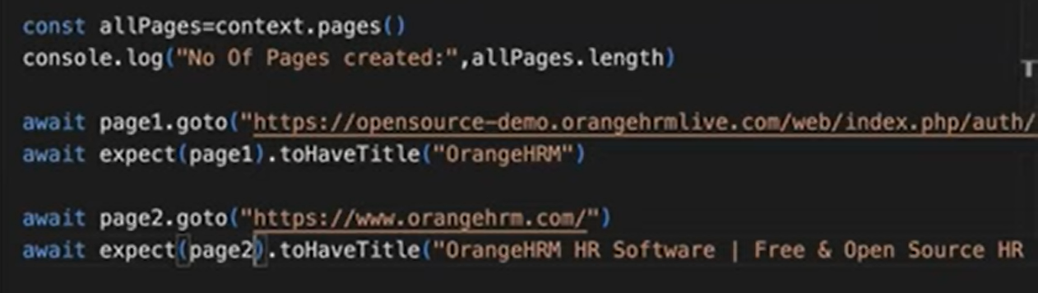

# Open One page and navigating to another URL from same page:

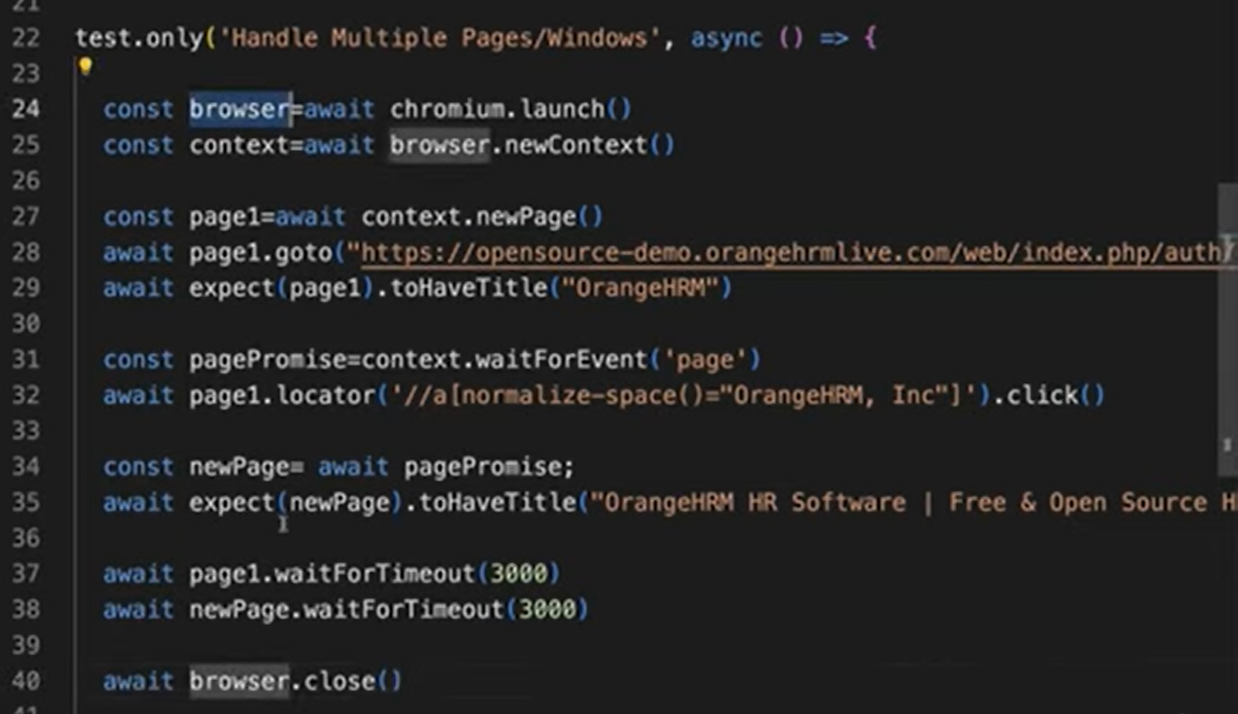

## 

## This will open new page with empty tab.

## Then we click on the link and open new URL in new tab.

# Reporters

## Provides built in reporters.

# List Reporter

# Approach 1: Config file

## In config file just mention reporter:list.

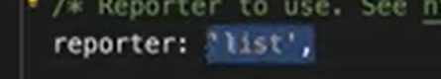

# Approach 2: Command line

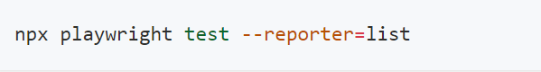

# HTML reporter

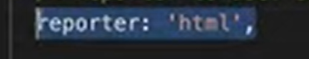

# To Generate multiple reporters

## Define as below in config file.

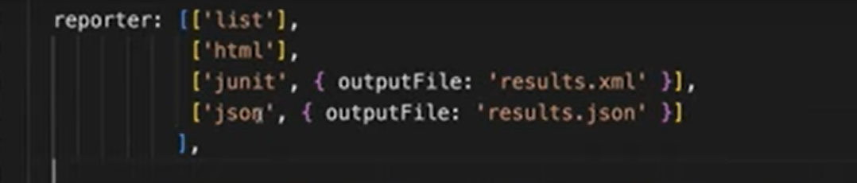

# Third party Customized Reporter

# Allure Report

## Popular third-party report in playwright.

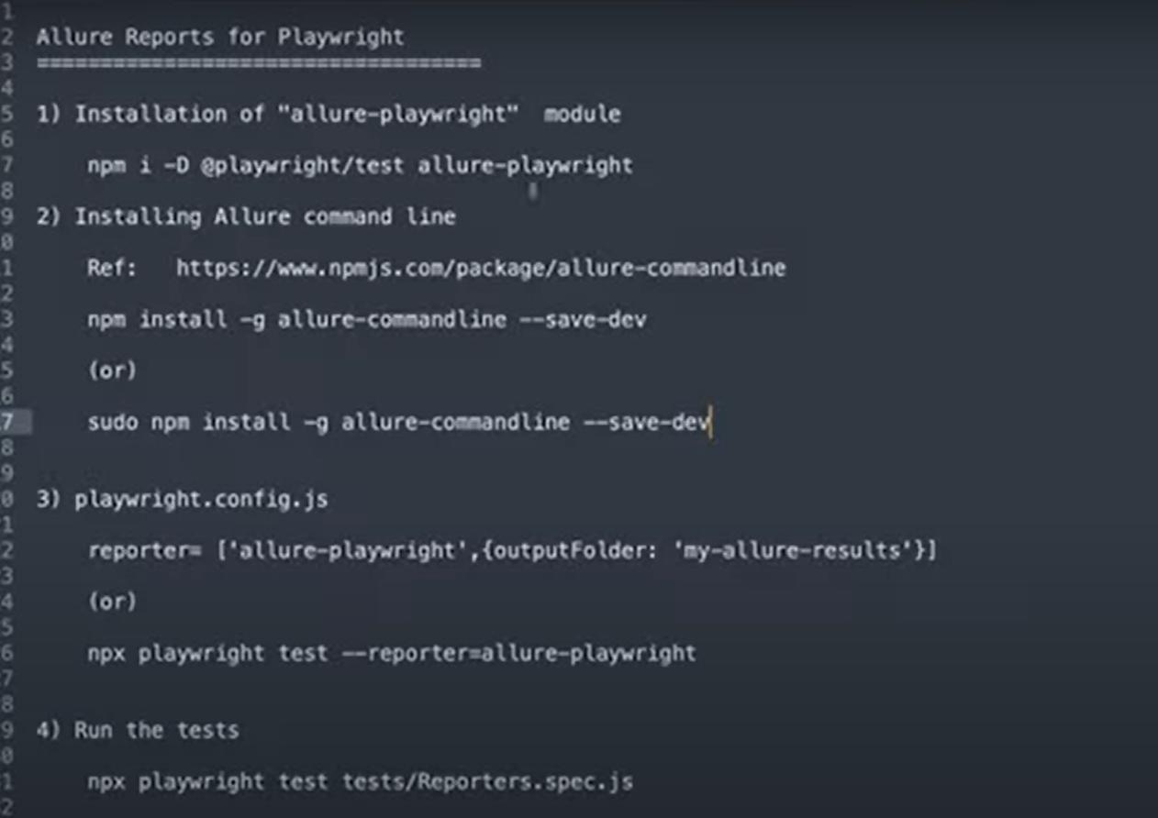

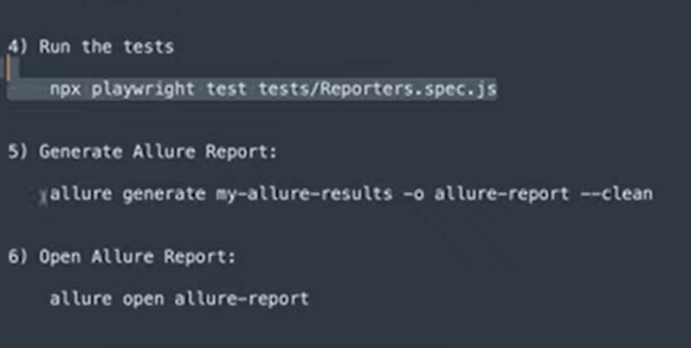

# Allure Installation

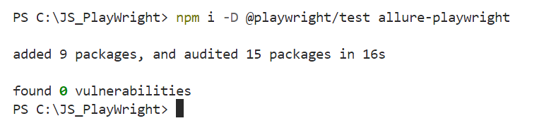

# Allure Command Line Installation

## We require this command line to run allure related commands.

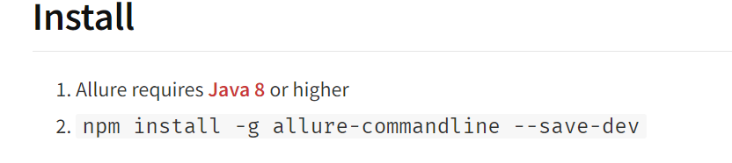

# Retry failed Test Cases

## If any test case, got failed we must rerun manually.

## If the test case, got failed because of some intermittent issue and again if you run that test it will pass. This is flaky test.

## After retrying also if the test case got failed then the problem is with the test case.

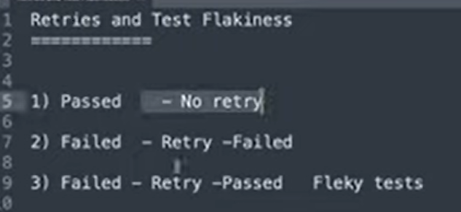

## In config file we must mention if retry is required

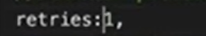

# API Testing

## For API testing we take help of request fixture

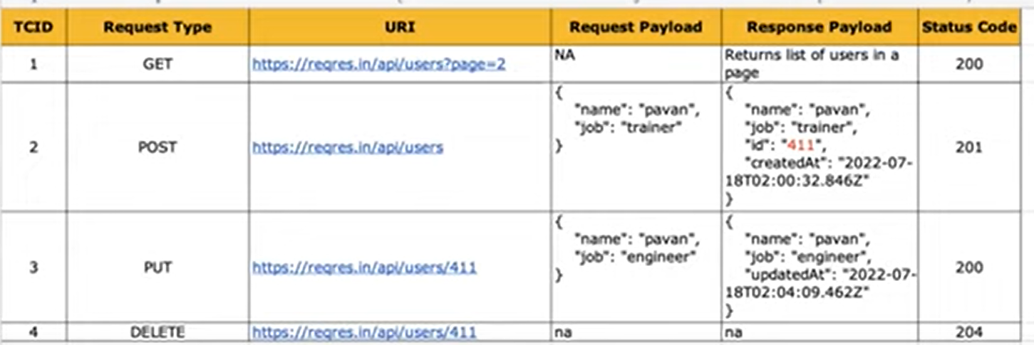

# GET

## Once you send the request it will provide one response that we will store in a variable.

## By default, it will return Json format. So, print it in console.

## response.json() – will return the JSON response. Whatever response we captured here that response will be printed in JSON format.

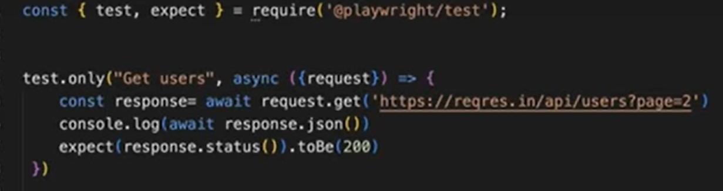

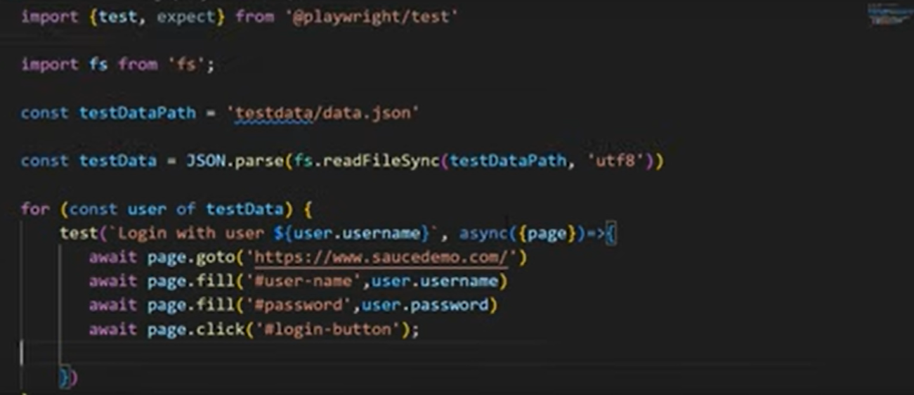

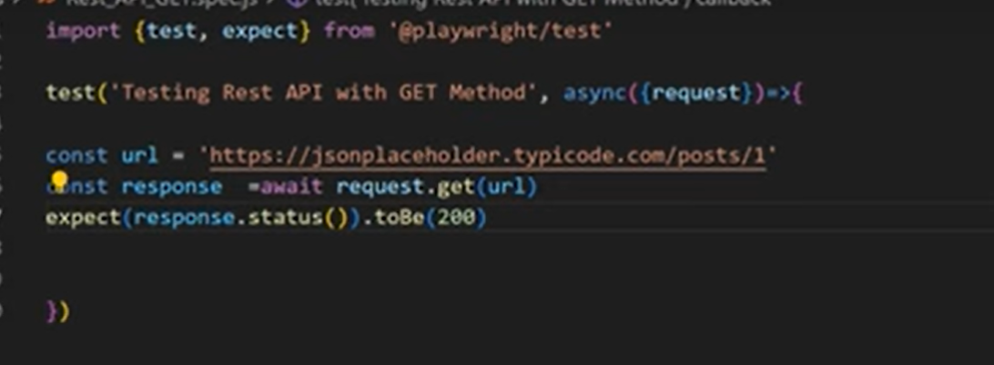

# To install env file

